Forced Marriages and Divorces in Alberta
Name
Institution
Date

Forced Marriages and Divorces in Alberta
Forced marriages and divorces are among common in the modern society. In Alberta, marriage still remains as one of the most crucial social institutions. However, the general marriage rate is significantly declining since it currently stands at 65.8 percent of Canadian families from 70.5 percent in 2001 (Evans, 2017). In addition, Alberta is one of the main provinces of Canada and it is attributed to high numbers of forced marriages and divorce. There are 27 percent more divorces in Alberta compared to other provinces in Canada. People in this province marry at an early age hence the justification that the younger you marry, the likelier you are to get divorced.
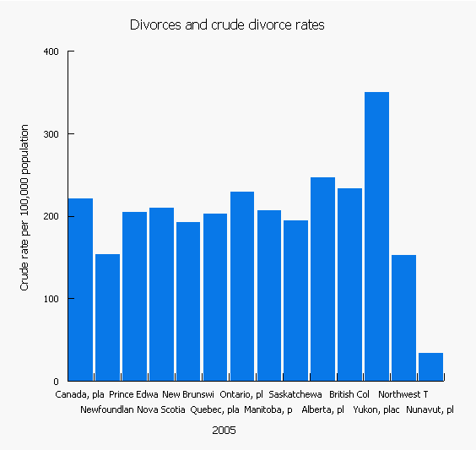

As such, young people between the ages of 22-24years who marry in Alberta are likely to divorce at a high rate compared to individuals who marry between the ages of 25-29. Besides, individuals who wait until they hit their mid-30s or later have a 43 percent lower risk to go for divorces. Canadians are mostly involved in forced marriages and divorces compared to other races. In regards to forced marriages, some girls are not able to identify their rights since they live in cultures and families that force and condition them to think and accommodate the idea that getting married is their only destiny. Women are likely to suffer from forced marriages compared to men. Some of the experiences faced by women are threats, violence, stress, poverty and being denied of basic needs. In other words, forced marriages are regarded as total abuse since it denies women development opportunities which may improve their lives (Puzic, 2018).


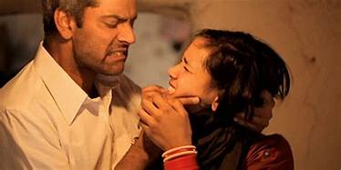
Forced marriages and divorce affect the community negatively (Evans, 2017). This is because relationships are interfered with hence influencing the designed family set-up. In my community, different supports are available for women as a way of attempting to reduce forced marriages and divorce. The first support care is the Divorce Care, which cares for women who have been divorced or have divorced willingly. In my community, they hold their meetings in places such as local churches and public schools as way of increasing awareness to women. Again, they consider viewing documentaries and videos with meaningful information from top divorce experts as a way of providing insights to women.
The Divorce Care is also crucial in my community since it provides resources that enable women to rebuild their lives again. Partners in prevention is also a critical support group in my community that aims at providing interventions as well as the prevention of domestic violence and abuse. This is well done through effective training programs from different healthcare givers. Some of the healthcare givers include; doctors, nurses and therapists among others. These specialized persons use their experiences in providing services that can help women reduce violence and abuse through healing (Laplante & Fostik, 2016). This supports women who are usually unable to end their abusive marriages in the community. These supports have significantly helped women who live in abusive marriages to find an edge as they seek ending their lives further. The divorced women are also funded with resources and moral support as they rebuild their lives again.

References
Evans, K. A. S. (2017). Forced Marriage in Canada: To Criminalize or Not to Criminalize. Canadian Journal of Human Rights, 6(1).Retrieved from https://cjhr.ca/articles/vol-6-no-1-2017/forced-marriage-in-canada-to-criminalize-or-not-to-criminalize/
Laplante, B., & Fostik, A. L. (2016). Cohabitation and marriage in Canada. The geography, law and politics of competing views on gender equality. Albert Esteve, 59.Retrieved from https://link.springer.com/chapter/10.1007/978-3-319-31442-6_3
Sonja Puzic, CTVNews.ca ‘’Forced marriage in Canada 'more prevalent' than thought: ex-child bride,’’ 22 June 2017 Retrieved from https://www.ctvnews.ca/canada/forced-marriage-in-canada-more-prevalent-than-thought-ex-child-bride-1.3471441.

